AERO 315

EQUATIONS

Fluid Mechanics
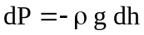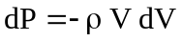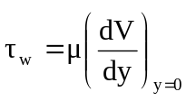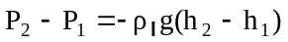

Viscous Flow

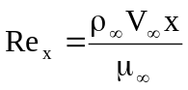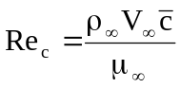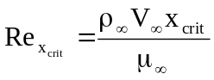

Airfoils & Finite Wings
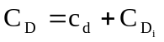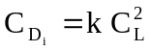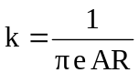
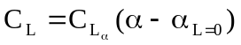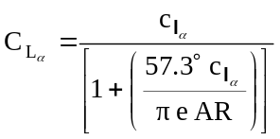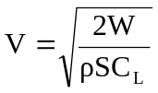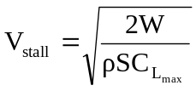

ICE-T
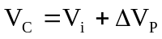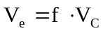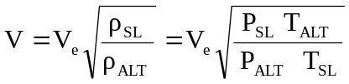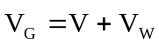

Mach Effects
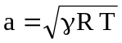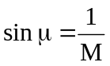

Stability & Control
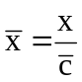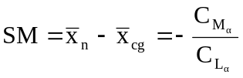

Performance
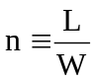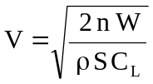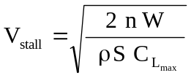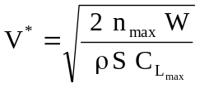

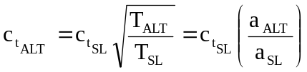

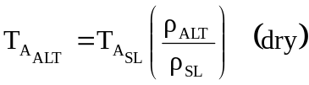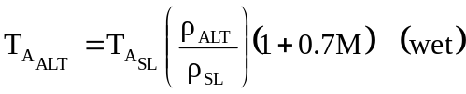

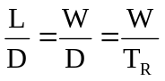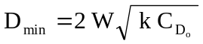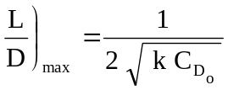

Glides
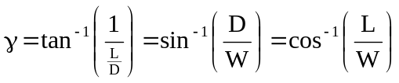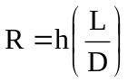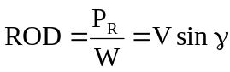

Climbs
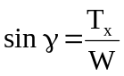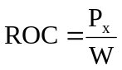

Cruise
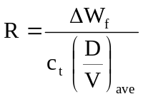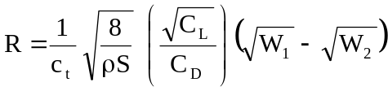

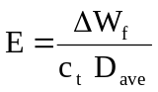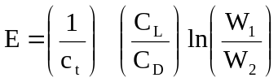

Take Off / Landing
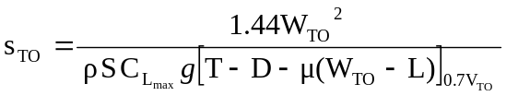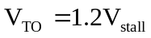

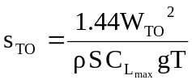 (thrust >> retarding forces)

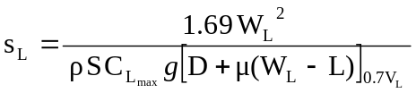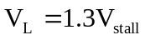

Steady Level Turn
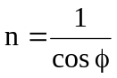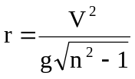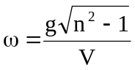

Pull-up (instantaneous, bottom of loop) Pull-down (instantaneous, top of loop)
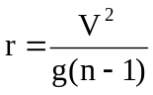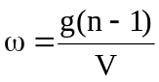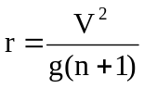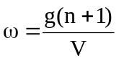

Energy Height & Specific Excess Energy
